Card Game Simulator – Proposal Document
Melanie Sverdlov

Game Overview
Card Game Simulator is a video game that aims to simulate various different card games in a tabletop way. The simulator lets players play on a virtual table, with each player having their own hand of cards, and play card games closely to how they would be played on a real-life table.
Players open game instances, and invite friends and other players to play their card game of choice. The game instances are played over a local network, with the devices within a short distance of one another, without requiring an active internet connection.
The game provides users the tools to build card games of their own, that let them set up different aspects of the game: card decks, player types, chatrooms, table settings, player actions and more. Cards can be added to a game using an image file, or by using the device's camera to take a picture of the card.
These game templates allow for quick setup of game instances, such as automatically handing out cards to players, and placing simple restrictions and permissions for players' actions. Game templates are stored in a central server, where players choose and download those templates to easily create new game instances.
In a physical meetup, players can use their devices to play, and a secondary device, like a tablet, can be used to project the current game being played. It can be used to display the game's table and players' scores on a larger screen, for everyone playing.

Purpose of the Project
The game can be used to accomplish two types of uses:
1. A complete replacement for playing a card game physically, where it would be preferred or even physically possible over playing with real-life cards. For example: a group of kids playing Taki with their phones on a bus.
2. An aid for players for use in card games, and board games that utilize cards in gameplay, for purposes of convenience or accessibility. For example: a game of Monopoly, where players have placed the game map on a real-life table, but the cards and player money management are handled on the simulator by the players.
The idea for this game was based on Tabletop Simulator and Board Game Arena - games that aim to simulate board games as a whole, including card games. Card Game Simulator specializes on card game simulation, and to add convenient features fitting for playing those games, such as an appropriate interface for showing the player's hand, quick access to player actions like drawing a card, shuffling a deck, and so on.
The Use of the Central Server
The central server will be responsible to serve game templates, that will be created and set up by the server administrators. Players will select from one of the available templates of the server in order to create their game instances. The server will also manage its user data and their permissions.
The game client will be set by default to the official central server of Card Game Simulator, allowing to quickly begin creating games and playing them with other players. The client will also have the option to set a different central server to connect to - the game's server software will be freely available and open-sourced. One of the reasons for that, is to allow for different servers to be created, other than the official one, and to allow for different communities to grow, and provide new game templates and features of their own.

Game Screens
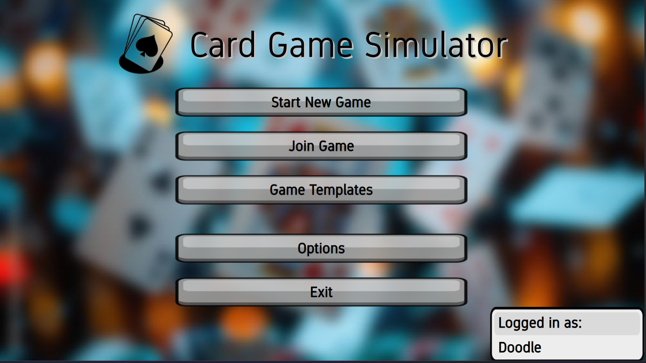
Main Menu (logged in):
...
Technologies at Use
The game client will be built using the Unity game engine, using it to easily and efficiently build up the game simulator, create a comfortable user interface, and to easily add new features and fix potential bugs.
In addition, Unity allows the game to be developed cross-platform - for desktop and mobile devices, and for different operating systems.
The game client and server software will be developed using the .NET framework, with the development environment being Visual Studio and Unity Editor.

